RESUME

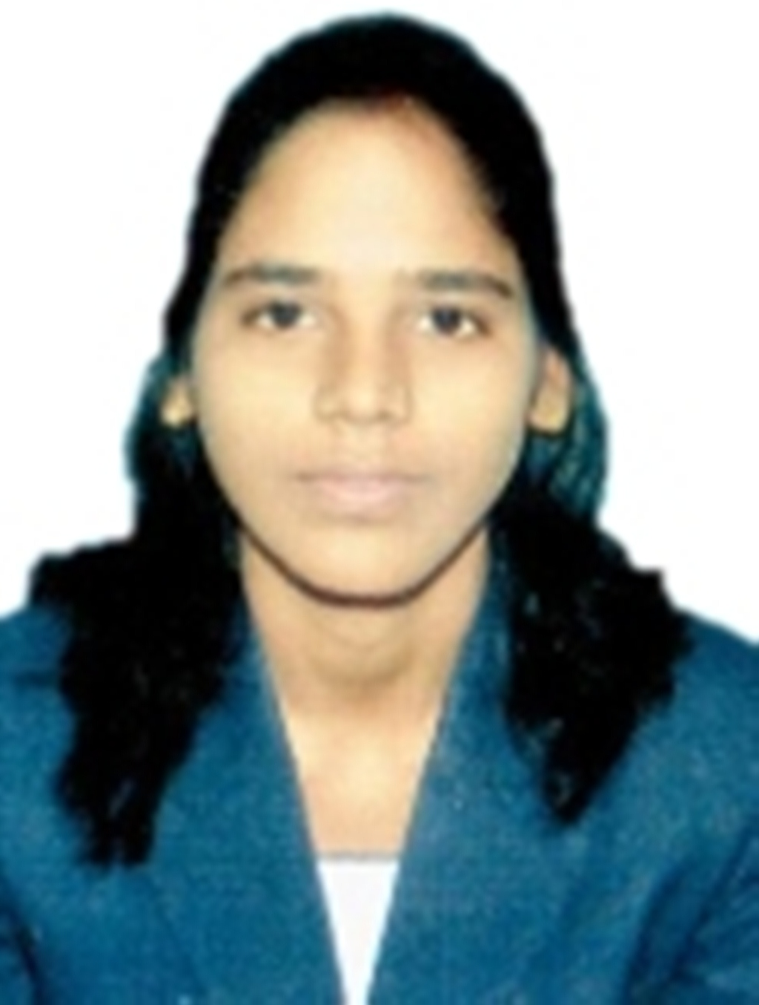
AMITA KUMARI
B. Tech (Applied Electronics & Instrumentation Engg )
BG 68 , 3RD FLOOR , MADANIR NEAR
META HOSPITAL , NEW DELHI,
110062
Mobile: + 91 9555521834
Email: amitaachand@gmail.com

Career Objective:
To insure as a hard core design professional and prove myself as an important part of the organization by achievement of given target and to work in a prestigious organization .

Academic Profile:

Sl No. | Academic Details | Year  of Passing | % of Marks/CGPA
1 | First Class Degree in B.Tech( APPLIED ELECTRONICS & INSTRUMENTATION ) FROM BIJU PATNAIK UNIVERSITY OF TECHNOLOGY(BPUT),Orissa | 2013 | 7.12(CGPA)
2 | 12th  NALANDA COLLEGE FROM BIHAR INTERMEDIATE EDUCATION COUNCIL , BIHAR SHARIF | 2009 | 63 %
3 | 10th  GOVT. HIGH SCHOOL FROM BIHAR SCH00L EXAMINATION BOARD , BIHAR | 2006 | 69%

Functional Skill:

Endowed with a passion for winning as evinced through demonstrated in the academic and extracurricular areas. Presently designated as a design engineer with M/S. Kudamm Corporation, New Delhi .

Acquired knowledge in E plan, Auto Cad, panel designing and calculation etc.

Good knowledge in type testing of panels as per IEC standards.

Extensive knowledge in Electrical equipment’s 3 phase AC motors , DC motor, VFDs , soft starter, solar & HES etc .

Hands on Experience with ABB , L&T , DELTA , ALLEN BREADLY products suc as ACB , MCCB , PID , VFD , SOFT STARTER , and Motor Protection Realy etc .

Testing & troubleshooting of all VFD and PLC panels .

Good knowledge of Building Management System (BMS) .

Capable of working independently with minimal supervision .

Vocational Training:
- Undergone vocational training on Familiarization of Thermal Power Electricity from NTPC ( BARH) BIHAR and also Allen Bradley make PLC System.

PLC Training:
- Completed the Certified Course for PLC , Scada System , DRIVE , HMI & PANEL DESIGNING at FUTURONIX Pvt. Ltd , NEW DELHI .

EXPERIENCE:

- Worked with M/S. KUDAMM CORPORATION PVT. LTD. , NEW DELHI, Othe authorized System Integrator of M/s. ABB as “PANEL CONTROL DESIGN ENGINEER” from 21.02. 2015. TO TILL DATE.

Accomplishment
- Working n with Electrical Power and Control Wiring with E plan P8 as well as Auto Cad.
- Work allocation , Query resolution , Project tracking , Project monitoring and project planning .
- Preparation of single line diagram (SLD) , Schematics & General arrangement (GA) Controls Panel .
- Switchgear Selection & Calculation Preparation of BOM.
- System Integration .
- Testing of Control Panels .
- Engineering VFD CONTROL PANEL , PLC Panel , SOLAR PANEL , SOFT STARTER PANEL & HES PANEL on a Project by Project basis .
- Detailed study of technical specification of project , customer requirement Selection of Drive (VFD) , PLC modules , Switchgear as per application requirement .
- Preparation of bill of material & electric Schematics drawing for panel manufacturing .
- Load estimation and transformer sizing , DG sizing , Size for Wiring Duct.
- Calculation of Voltage Drops , Switchgear Calculations and Selection of proper Size cables .
- Panel Heat Calculations .

Projects Undertaken
- Title : HPCL
- Description : Power and Intellient motor control Switchboard (Estimated & designed for the projects ) and ATS with parallel operation of two transformer incomer with bus tie.

- Title : BHEL PVT. LTD. (HARIDWAR)
- Description : 7. 5KW VFD PANEL FOR LB -20 LATHE.

STRENGTH AND SKILLS:
- Appreciate for Leadership and Organizational skill.
- Noticed and appreciated for steep learning curve and innovative ideas.
- Enthusiastic about new challenges and giving complete dedication till theend.
- Organizing and Managing events and activities.

Personal Profile:

- Father’s Name : Mrs. AMITA KUMARI
- Date of Birth : 05th Dec 1991
- Gender : Female
- Nationality : Indian
- Marital Status : Single
- Languages Known : English, Hindi and Odiya
- Contact Number : 9555521834 .

DECLARATION:
I do hereby declare that the above statements made by me are true to the best of my knowledge and belief.
Place : Bihar sharif

(AMITA KUMARI)

